**PYTHON PROJECT**

**Course Name: Python Programming**

**Course Code: INT213**

**PROJECT TITLE:**

**Design a Books Management System in LPU using python.**

**SUBMITTED BY:**

* **RK21WYB46** [Prince Kumar]
* **RK21WYA24** [Sonam Choden]
* **RK21WYB71** [Abhijeet Singh]

* **Project No: 23**
* **SUBMITTED TO: NAVPREET RUPAL**

**INTRODUCTION:**

**The project assigned to us is a book management system. Under this project, we have to develop a system that keeps the records like sales, re-sale and purchased books.**

**Our system takes input from the user and then processes the input according to the user’s requirements like whether the user needs to register or log in and submit or request a book and then provides desired output.**

**The backend is developed by Python and the front end is G.U.I.(Graphical User Interface) is developed by Tkinter.**

**We have to make a Books Management System in LPU using python in this project. for that, we have five modules BMS module, register module (where we can register new users), login page(where we can log in), submit book module, and request book module(you can order the book). using this project users can register, log in, see the Available books, submit the books, and also request the book.**

**OBJECTIVE:**

**The objective of this project (books management system) is to manage the books and maintain the records of available books. and it can be used to sale books or order books. Users can log in and order the book or sale the book using submit book module. by using this system users can easily able to buy the book or sale re-sale the book and new users can register in this by filling in some credentials and being able to use the features of this system.**

**You can find books in an instant, issue/reissue sale the books quickly, and manage all the data efficiently and orderly using this system. The purpose of a book management system is to provide instant and accurate data regarding any type of book, thereby saving a lot of time and effort.**

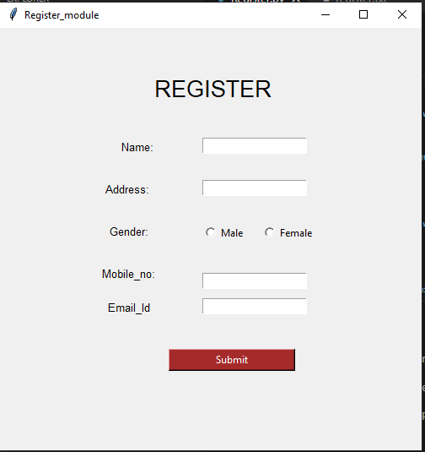

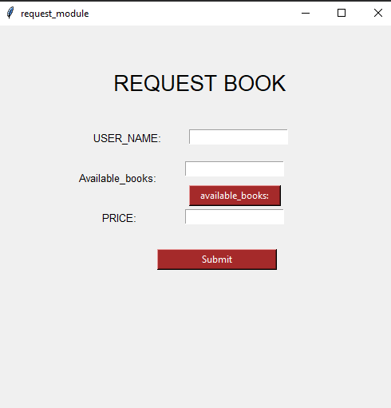

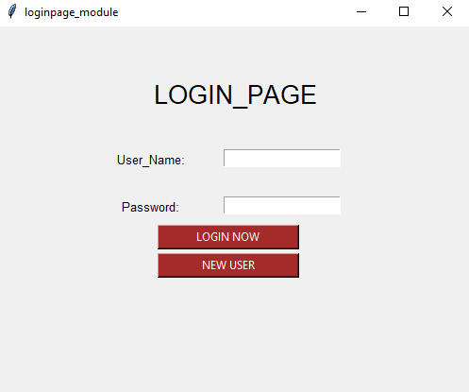

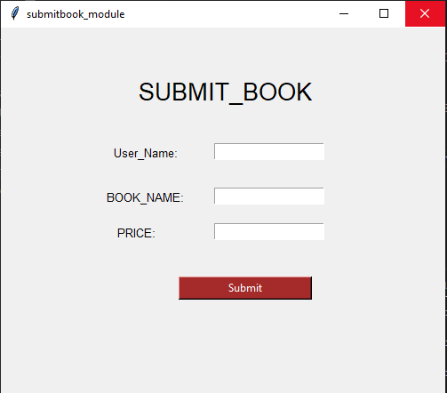

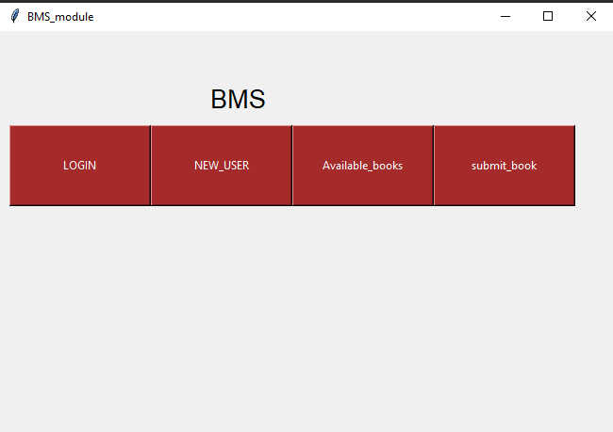

**Conclusion:**

**The user interface is very easy to use and everyone can use it easily. By using this system users can sale, re-sale, and purchase books.**

**And the user can able to see the available book with their price so that he/she can order them easily.**

**And if a user wants to register in the system this can be done easily using the register module. And existing users can log in using the log-in module.**

**The books management system is an attempt to overcome the present efficient and time-consuming process of locating reserving and purchasing quality reading materials available in the university. Automated library solution, provide an easy way of searching reserving, and purchasing books. It's worth analyzing and identifying the benefits as it would directly influence the productivity of the library.**

**References:**



